**Java Database Connection with JDBC and MySQL**

You will learn how to:

- Connect to a MySQL Database with Java

- Submit SQL statements to insert, update, and delete data

- Handle SQL parameters with Prepared Statements

- Call stored procedures and handle various parameter types (IN, INOUT, etc.)

**JDBC Overview**

In this part, we will learn how to use Java and JDBC to connect to a database. We’ll first start off by explaining what JDBC is, then we’ll cover the features, architecture, and also cover the development process.

What is JDBC?

JDBC allows Java applications to connect to a relational database.

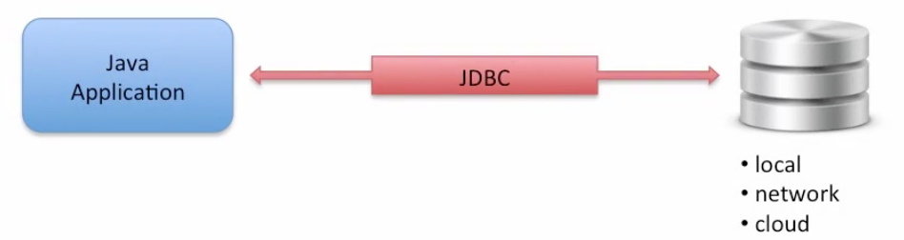

The main feature of JDBC is that it is a standard API. You develop your application code and you can connect to various databases. There’s no need to develop different code for different databases; that’s the main advantage of JDBC. You simply provide **SQL statements** to a **JDBC Driver** and it will pass those statements on to the **database**. You can also build your own custom SQL statements. You can make use of insert, select, update, and delete.

The JDBC architecture includes a key component, which is the JDBC Driver. This Driver provides the critical **link** between your Java application and the database. The JDBC Driver converts the standard API calls to low level calls for your specific database. Your database vendor normally provides the JDBC Driver file for you. Another key player is the JDBC Driver Manager. The Driver Manager helps connect an app to a database based on a database **connection string**.

The JDBC API is defined in the following packages:

* java.sql and javax.sql

The key classes in the JDBC API are:

* java.sql.DriverManager
* java.sql.Connection
* java.sql.Statement
* java.ResultSet
* javax.sql.DataSource *(for connection pooling)*

Let’s go over the development process. Basically what you need to do is:

1. Get a connection to a database
2. Create a Statement object
3. Execute SQL query
4. Process Result Set

Let’s take a look at the first step. So in order to connect to a database, we need to **find** the database. It can be a local database or somewhere on the network. We use a similar approach of finding a web resource and that’s via URL. We make use of a **JDBC URL**. So, the JDBC URL is effectively the **connection string**. The basic syntax of a JDBC URL for MySQL is jdbc:mysql://localhost/mySchemaName. The “mySchemaName” part is whatever you name your schema/database in MySQLWorkbench and we’ll get to that later.

Now we have enough background information to get a connection to a database. In this example code snippet below, I will define variables for database URL, the userID, and the password and then make use of DriverManager.getConnection() based on these variables:

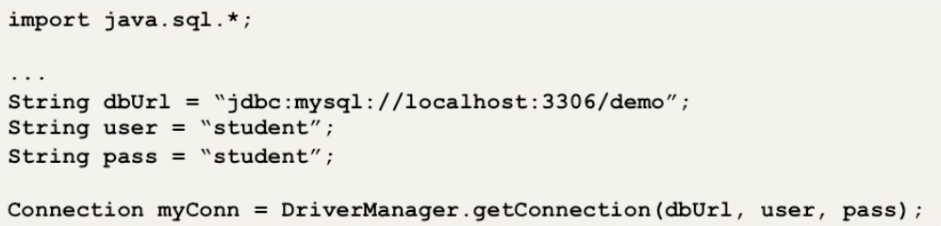

If everything is **successful**, then we get a valid connection object. If there’s a **failure**, it can throw an exception like a *SQLException* or a *ClassNotFoundException.*

Now that we have a connection, we can move onto step 2: Create a Statement object. I’ll make use of the myConn object in the code snippet example below and say myConn.createStatement(), which returns a statement object, which is the basic object we will use later on for executing SQL Statements.

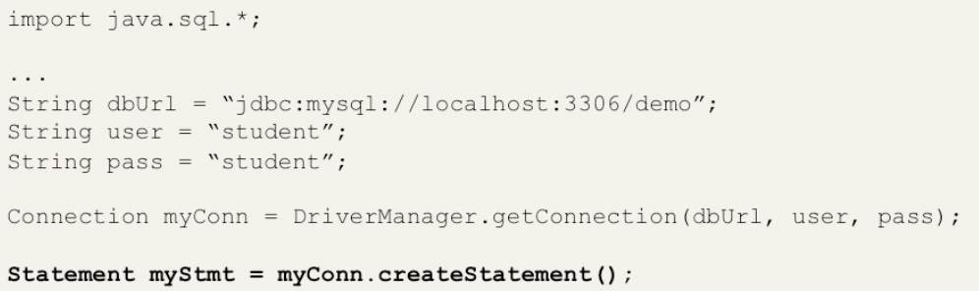

In step 3, we use the statement object to execute a SQL query. So, in this example, I’ll say myStmt.executeQuery(“select * from employees”); which will return a Result Set.

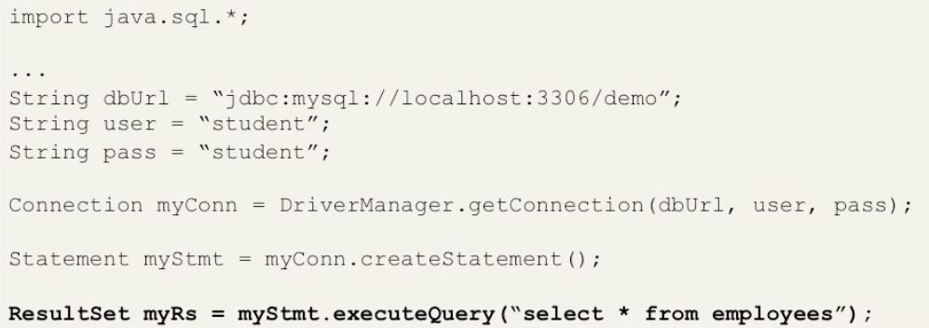

For step 4, we’ll process the Result Set. The Result set is initially placed before the first row in a database table. We make use of the ResultSet.next() method by moving forward one row to read a row from a database table. This method will also return true or false if there are more rows to process. So, we can use this ResultSet.next() method in a loop to process each row in a Result Set.

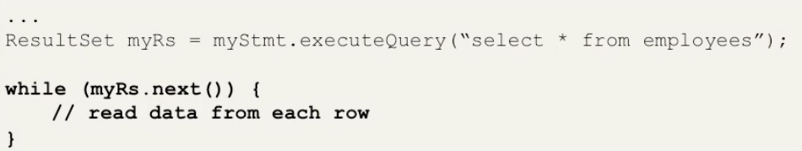

When we are in the loop, we can read data from our database using getter methods. We can look up the data based on column name or the column index. It’s important to know that the column index is one-based. In this code snippet example below, we are printing out the *last name* and *first name* for each row in the Result Set.

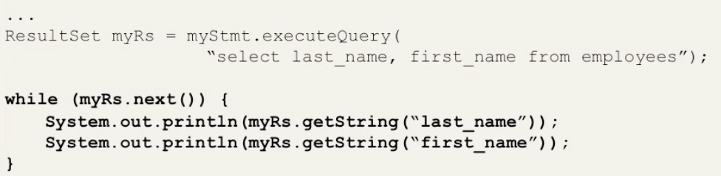

So, for recap, this is the basic process to execute a query with JDBC:

1. Get a connection to a database
2. Create a Statement object
3. Execute SQL query
4. Process Result Set

Now that we have a firm foundation with JDBC, we will run some Java code!

**Install the MySQL Database**

With this lesson, you will learn how to install MySQL Database. Let’s get started!

1. For Windows, watch this to install MySQL & MySQLWorkbench:

<https://www.youtube.com/watch?v=ZqZClGf_-DA>

1. For Mac:

<https://www.youtube.com/watch?v=WRQ7E3Qby5U>

Also, if you watch the Mac video at (3:44), it is optional to set new passwords, so you don’t necessarily need to follow that part of the video unless you want to. Your default username will be “root” and your password will be empty “”.

**Setting up the Development Environment**

Open up your MySQL Workbench and create a new connection by clicking the plus (+) icon at the top left of the program window. Name your connection “localhost”, don’t bother messing with any other field and click “Test Connection” to see if you are able to make a successful MySQL connection. When that’s done, click “ok” and you will see your newly created MySQL Connection!

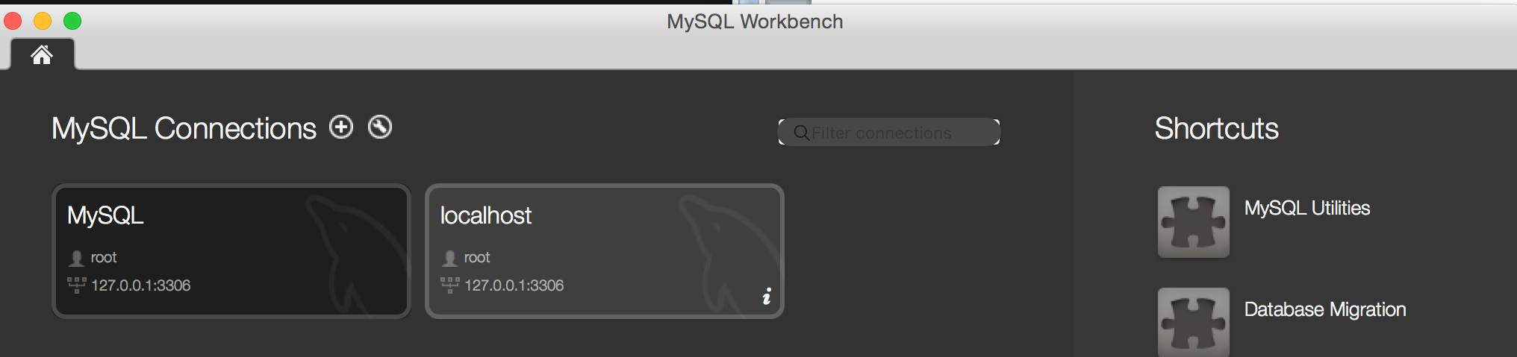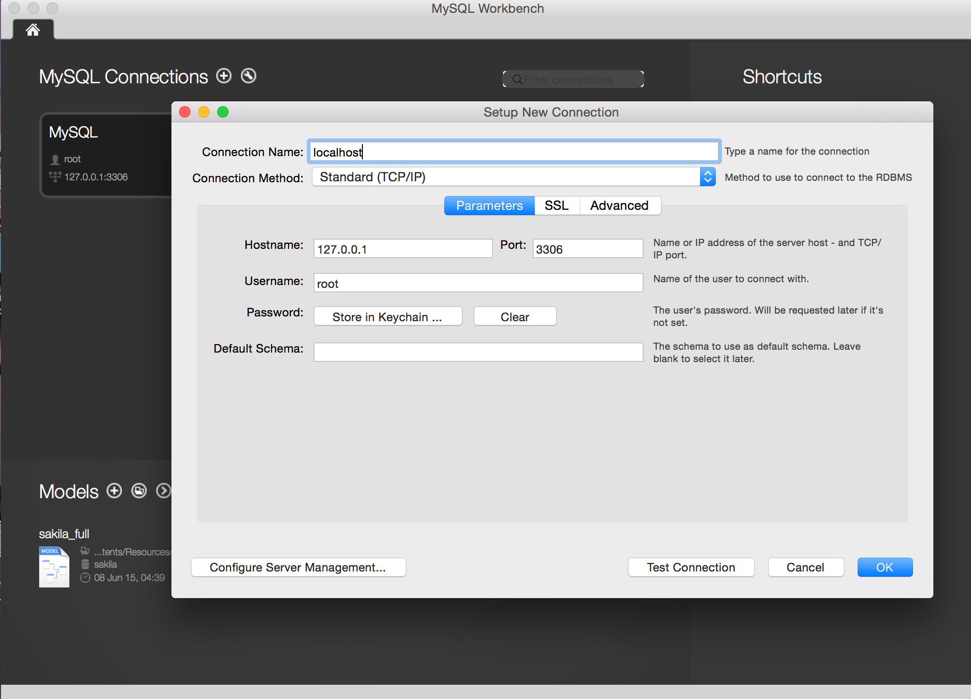Click on the (i) info icon located near the bottom right of your MySQL localhost connection bubble and click “Connect”

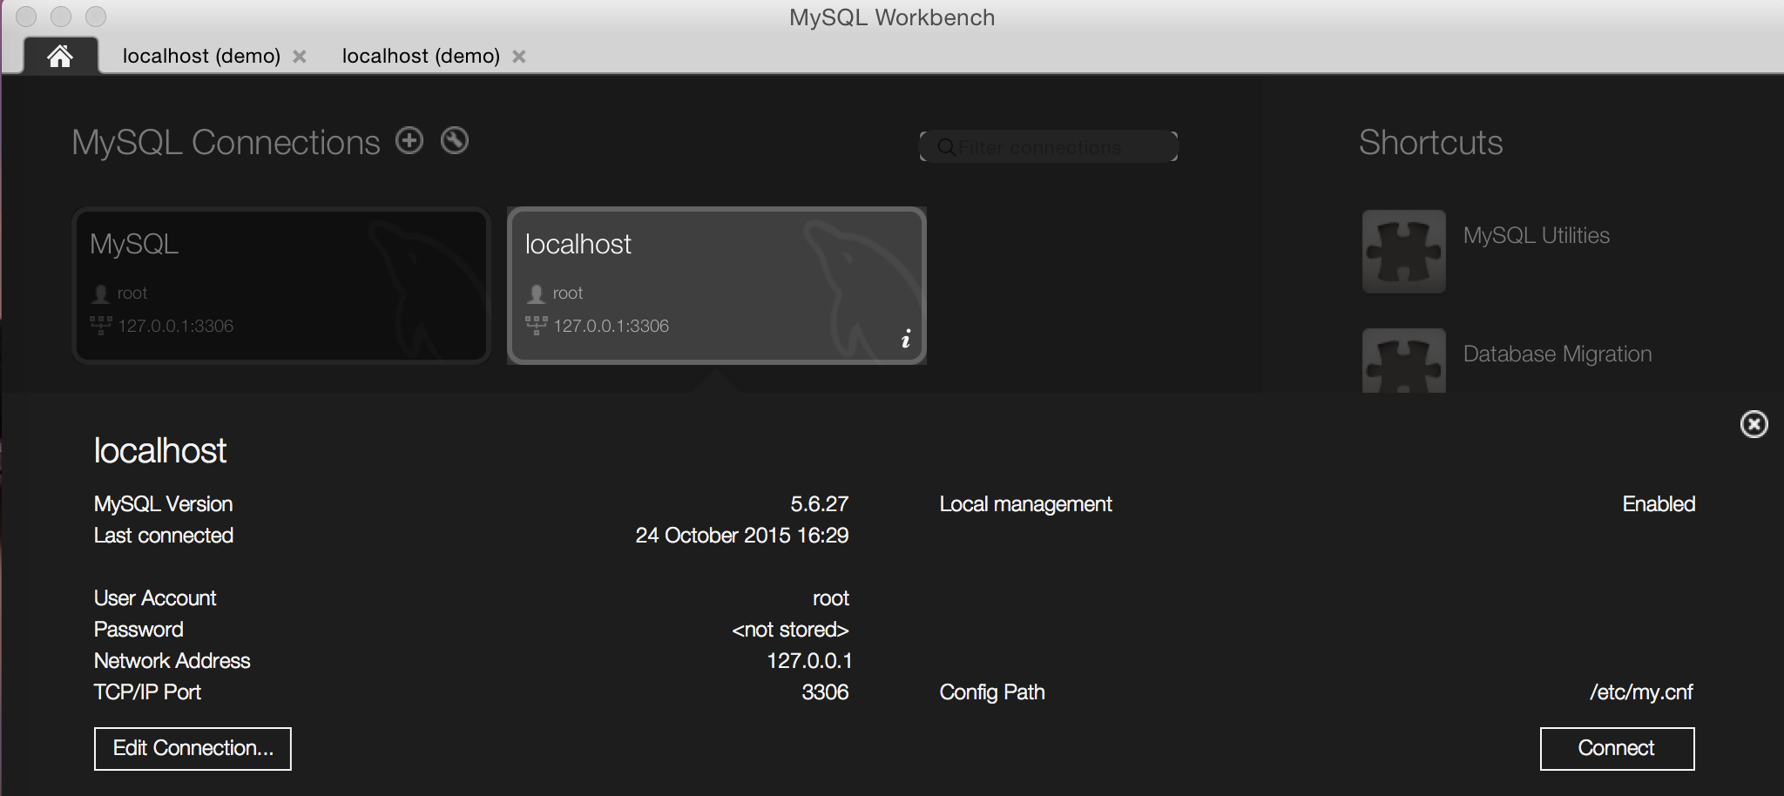

To create a new database that we can interact with, create a new schema. It’s the stacked cylinder icon towards the top left of the program screen.

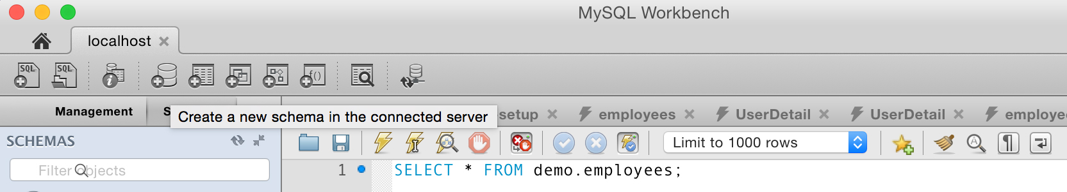

Give your schema a name, let’s say “MyATMSchema” and click “Apply” at the bottom right. You will be prompted with a popup window asking to review the SQL script to be applied on the database, just leave the Algorithm and Lock Type as Default and click “Apply” and then on the next popup click “Close”.

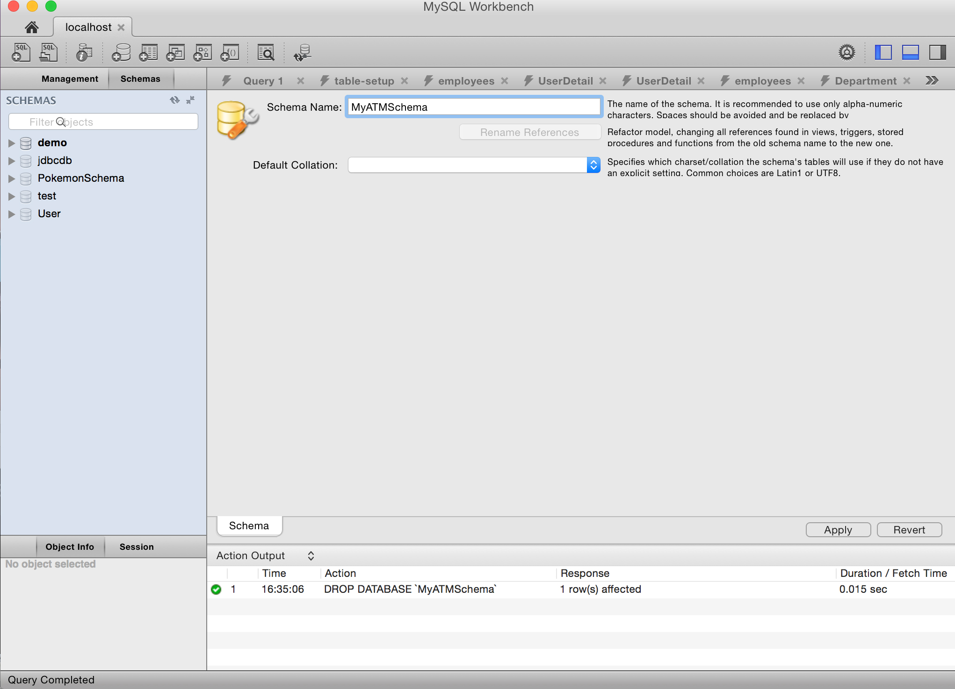

Now we’ll create a new Table to store our database data in. Click the dropdown next to the schema you created, and right click on “Tables” and click “Create Table…”

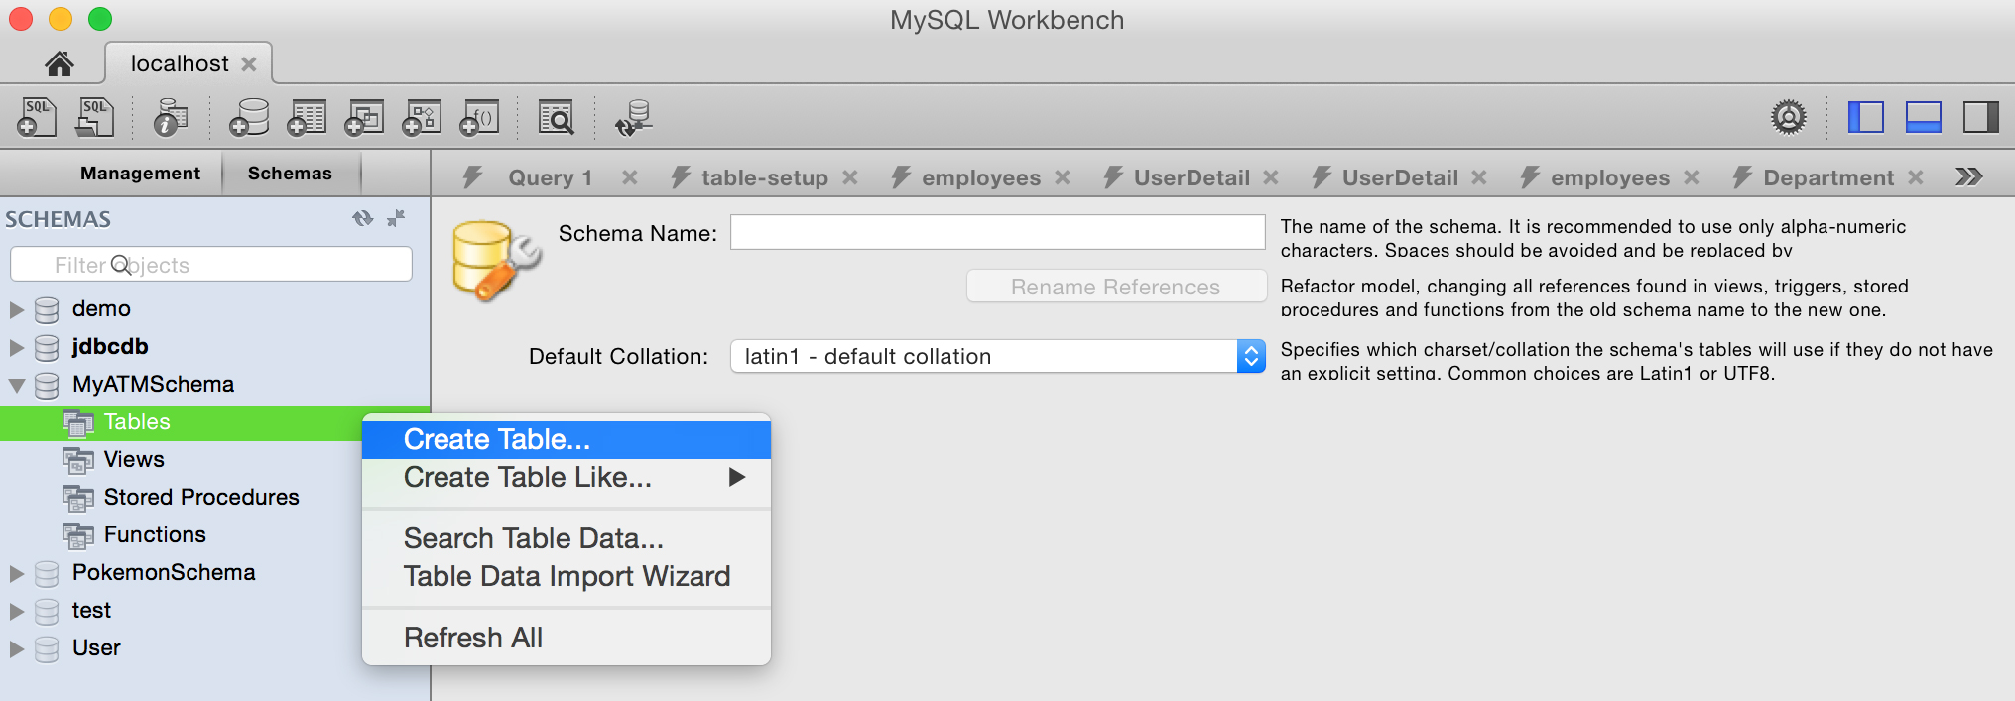

Give your Table a name, such as “MyATMTable” and add some column and datatype information. Going off on a tangent, if you want a column datatype to be a string, I’d recommend using the datatype VARCHAR(). The value you put in the () in VARCHAR is the length of characters or constraint of data stored in the column. In my honest opinion, the length should make sense with respect to the data. For example, if you’re storing a SocialSecurityNumber column, it makes no sense to set the VARCHAR length to something like 128. For this database project, we will use the following columns and datatypes with these checkmarks:

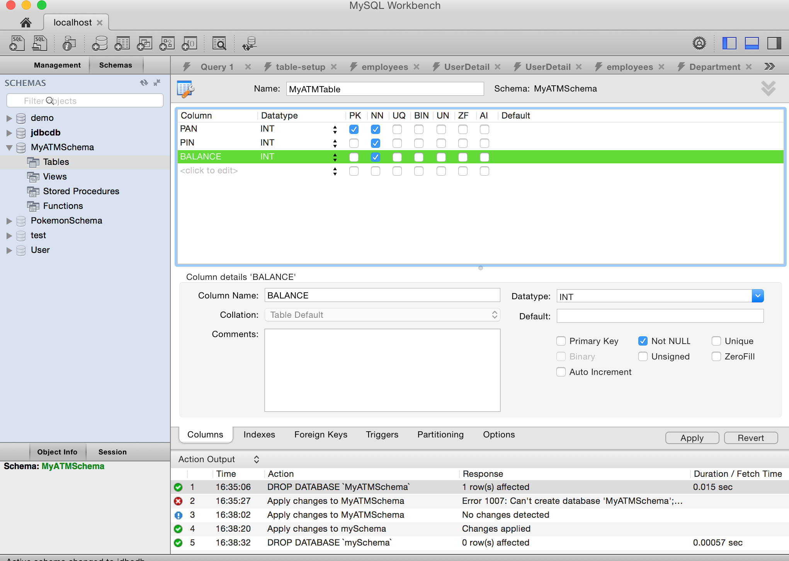

For more info, PK is the Primary Key, which uniquely identifies each record in a database table. Primary keys must contain unique values and they cannot contain null values. Most tables should have a primary key, and each table can only have one primary key. NN means Not Null. By default, a table column can hold null values. The NN constraint enforces a column to not accept null values. In this case, we want a user to always have a PAN, PIN, and a balance, so we set these to NN (Not Null).

Click “Apply” at the bottom right, then click “Apply” again when prompted with the popup, then click “Close”.

Congratulations! You now have set up a nice SQL database table! The local database setup work is now pretty much done ☺

To see your newly created table, navigate to the left of the screen to find your schema and click the drop arrow next to “Tables”, then right click on your newly created table, for me it is “MyATMTable” and click “Select Rows – Limit 1000” to view your table data.

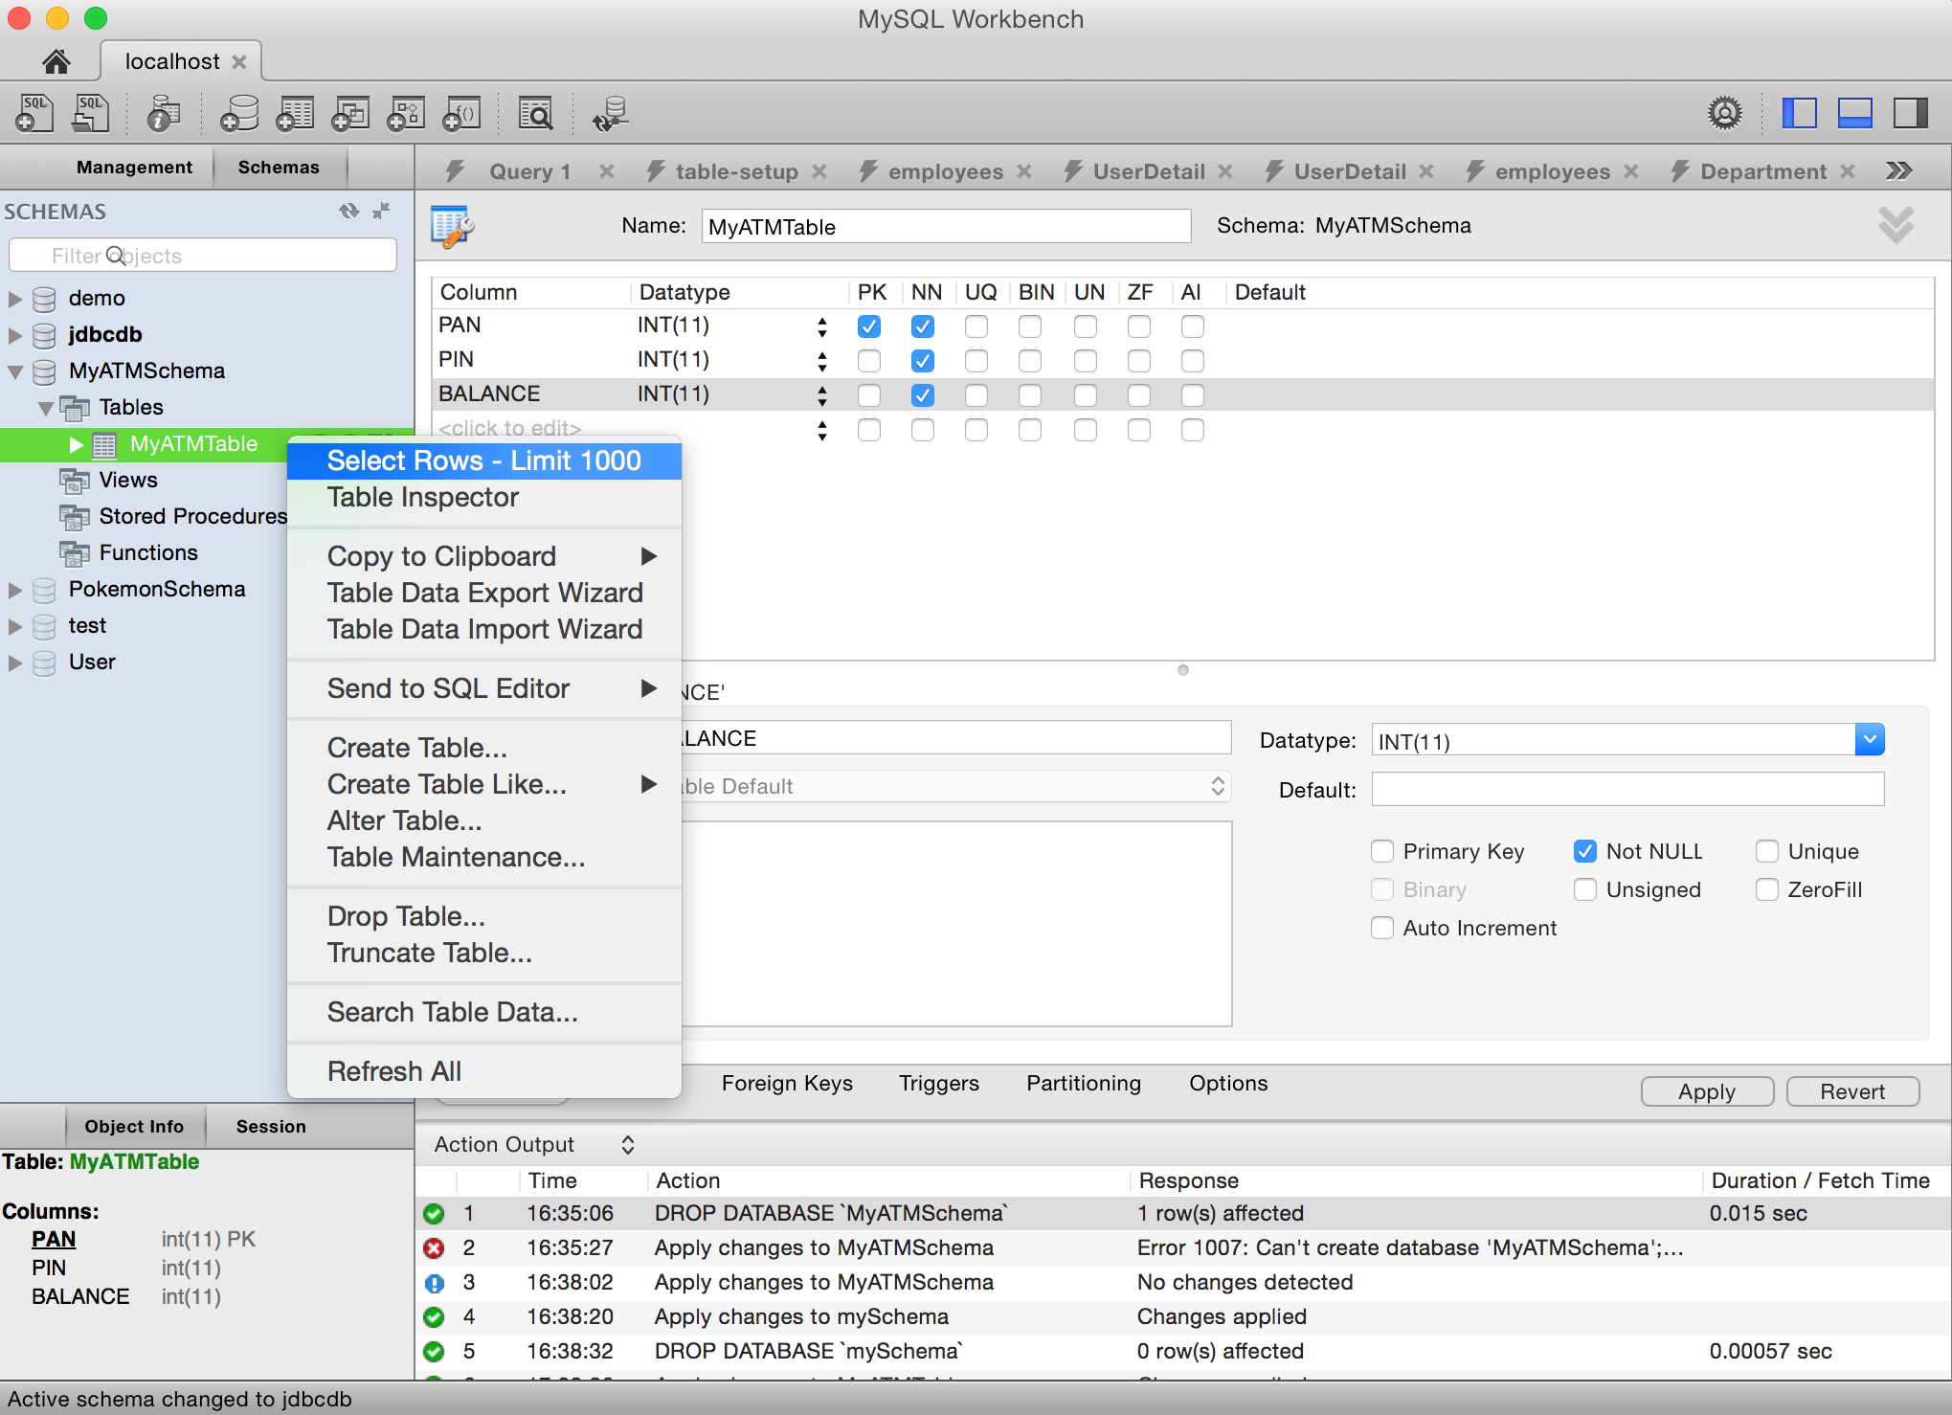

Add some row data for your columns by clicking under a column name, then click “Apply” > “Apply” > “Close”.

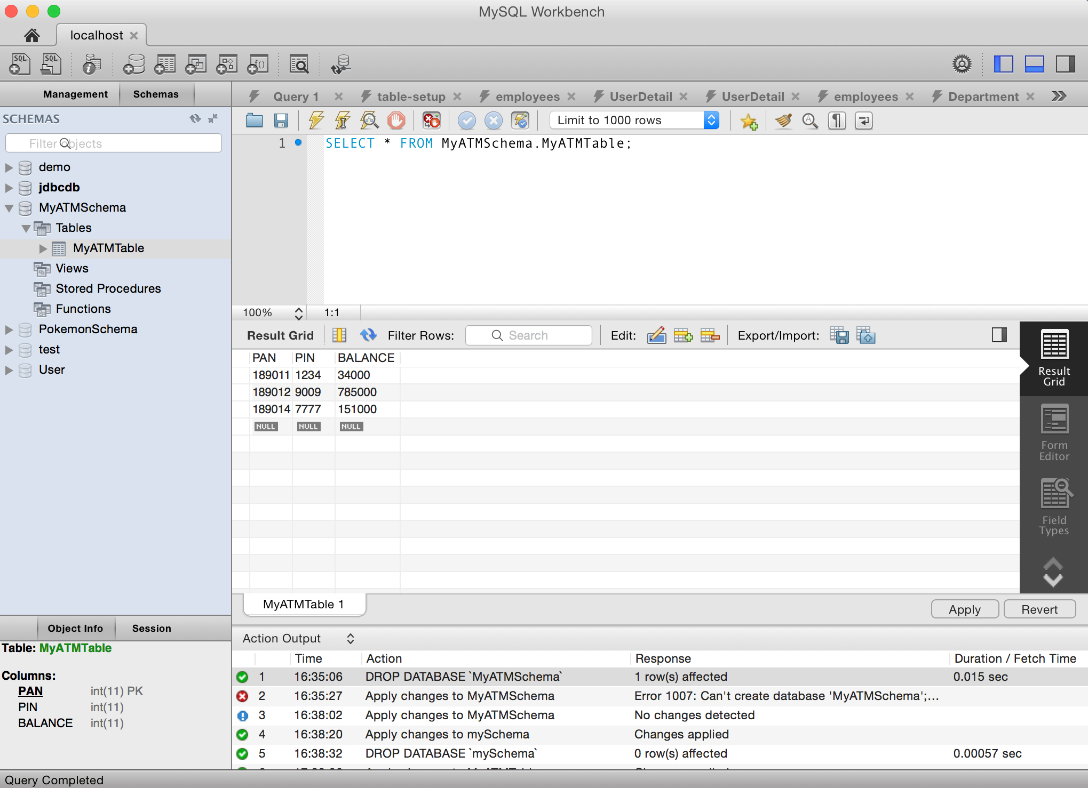

**Install JDBC Driver**

What we’ll do here is download the JDBC Driver and then configure the JDBC Driver in Eclipse.

Go to: <http://dev.mysql.com/downloads/connector/j/>

Download the Platform Independent ZIP Archive (choose “no thanks, just start my download”).

Extract the ZIP file and locate the jar file: “mysql-connector-java-5.1.37-bin.jar”. FYI, the version of the file (5.1.37) may be updated/different depending on when you download it.

Open Eclipse and create a new Java Project. (File > New > Java Project). For the project name, I’ll name mine “MyATMProject” and click “Finish”.

Now we will add this external jar file to our Eclipse project. Right click on your project name (MyATMProject) > Build Path > Configure Build Path…

Under the “Libraries” tab, click the “Add External JARs…” button and locate the “mysql-connector-java-5.1.37-bin.jar” file and click “Open”, then click “Ok”

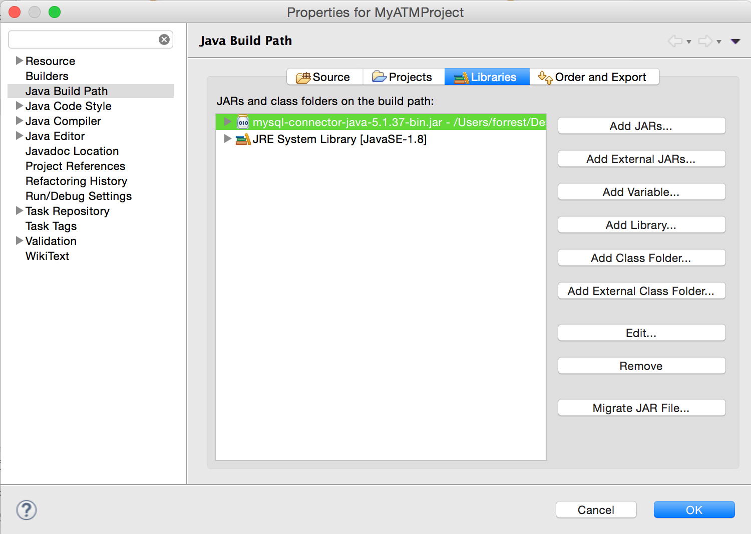

Were done with the setup! Yesssssssss! Now we can do the cool stuff.

**Submitting SQL Queries**

The development process is as follows:

1. Get a connection to database
2. Create a Statement object
3. Execute SQL query
4. Process Result Set

Now what we want is a very simple Java program for testing the JDBC connection. Add a new Java Class to your project named “JDBCTest” and add this code to it:

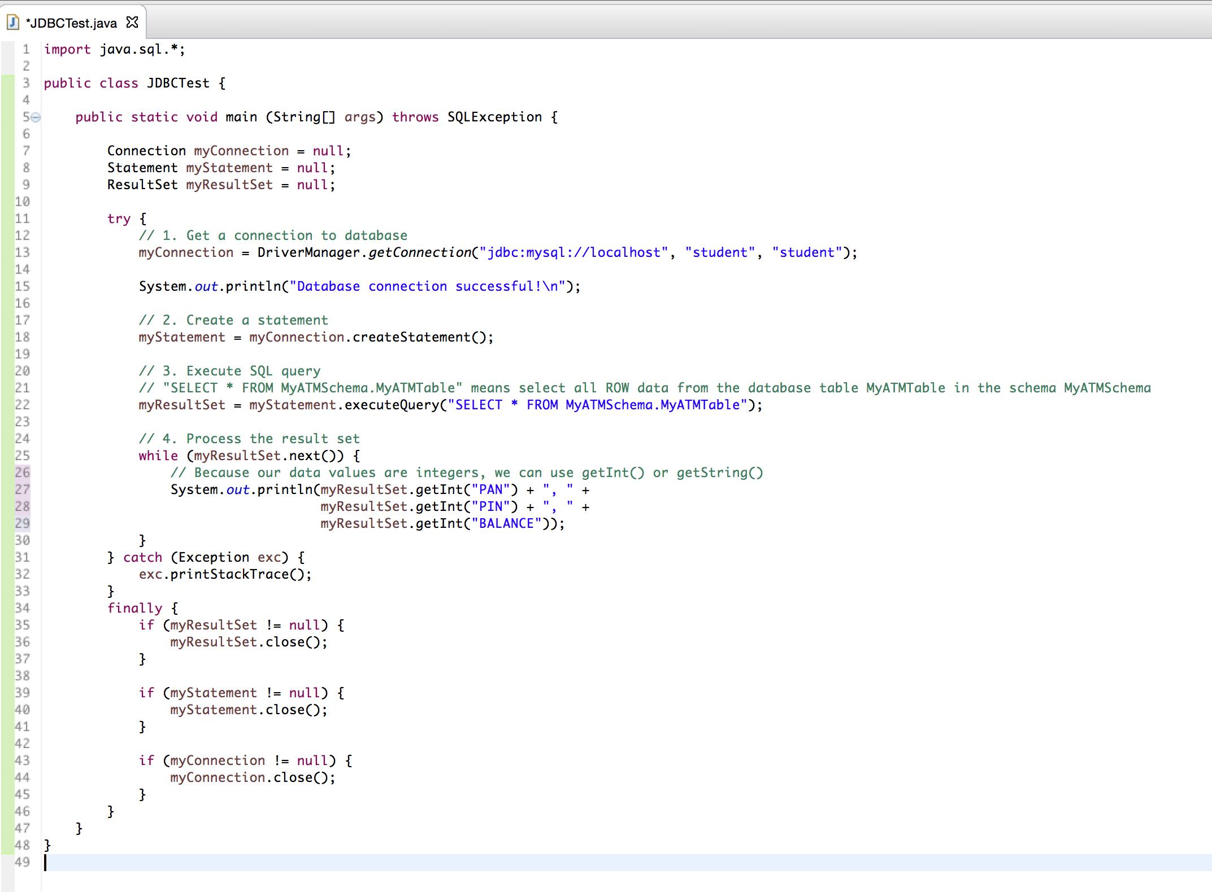

My username and password are both “student” as you can see from this code:

myConnection = DriverManager.*getConnection*("jdbc:mysql://localhost", "student", "student");

Your username and password will be different, so change “student”, “student” to your unique username, password. If you don’t know your username or password, just set it to this default configuration:

myConnection = DriverManager.*getConnection*("jdbc:mysql://localhost", "root", "");

If you choose to use “student”, “student” as your username and password, and run the program and get the following error:

java.sql.SQLException: Access denied for user 'student'@'localhost' (using password: YES)

In your MySQL Workbench admin tool, run the following script:

CREATE USER 'student'@'localhost' IDENTIFIED BY 'student'; GRANT ALL PRIVILEGES ON * . * TO 'student'@'localhost';

This creates a new account with user name "student" and password "student". Once this is complete then your program should get past the "access denied" error.

When you run the program successfully, you will see something similar to this console output:

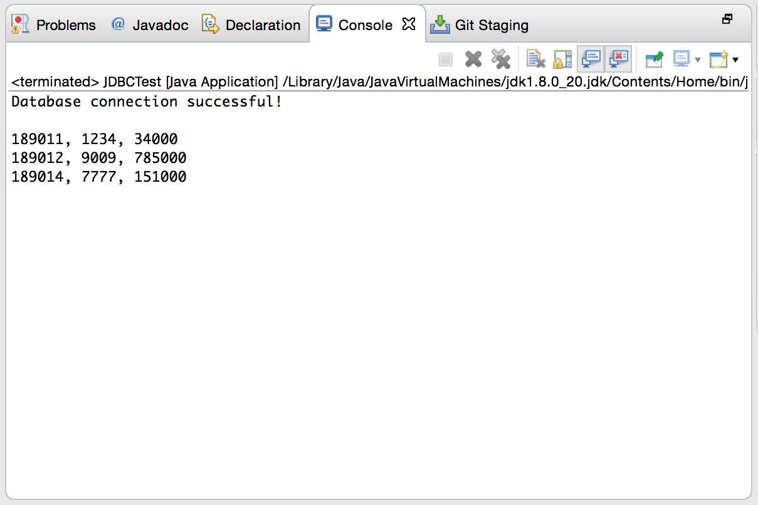

The output is a result of the query: “SELECT * FROM MyATMSchem.MyATMTable” that we ran. Great! So we are successful connecting to the database and also successful with submitting a query.

**Inserting Data into Database**

We want to insert data into the database. In order to accomplish this, we’ll follow this step-by-step development process:

1. Get Connection to database
2. Create a Statement object
3. Execute SQL insert statement

Edit your JDBCTest class with this modified code for the try-catch block:

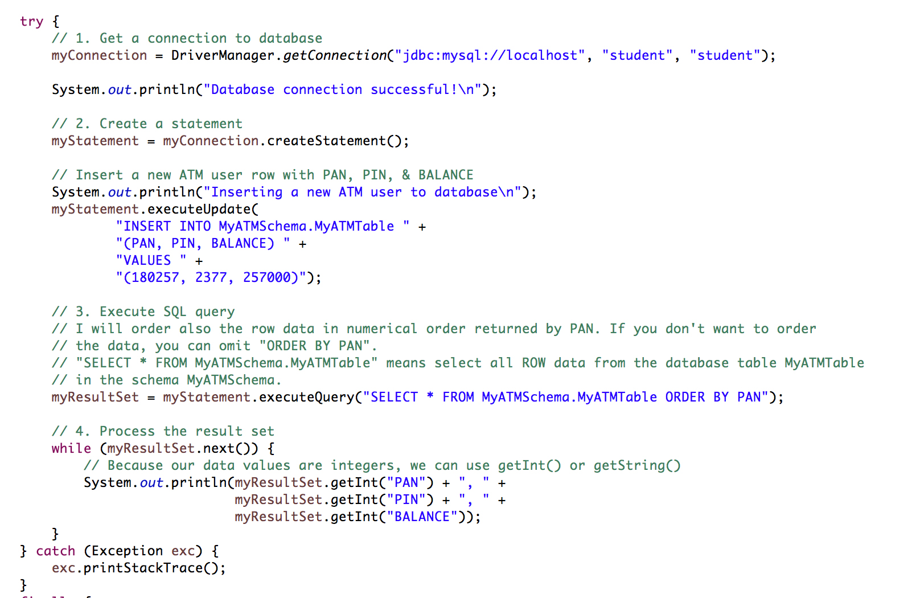

Console Output:

Database connection successful!

Inserting a new ATM user to database

180257, 2377, 257000

189011, 1234, 34000

189014, 7777, 151000

189012, 9009, 785000

You can also check that your MySQL Workbench database information has changed for the table “MyATMTable” by right clicking on the table and “Select Rows – Limit 1000”. You can also refresh your SQL database to the latest information by clicking the lightning bolt icon on the tab bar, which executes your database script. If you want to delete any of the rows you added, right click on a row and click “Delete Row(s)” then click “Apply” near the bottom right of the program screen.

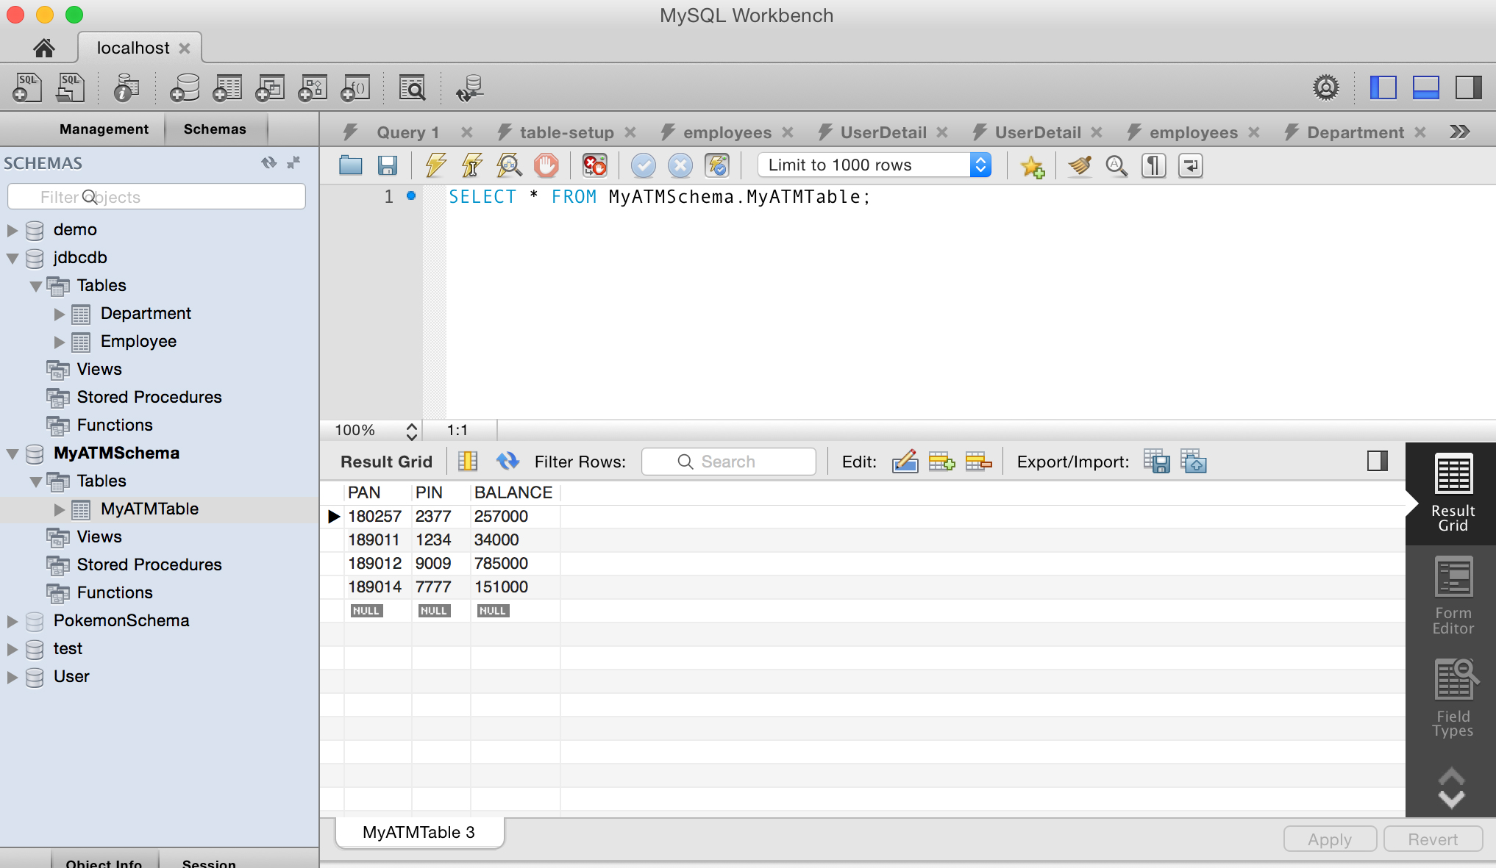

**Updating Data in the Database**

Say we want to update the BALANCE for a certain PAN. We’re going to write some java code to perform this kind of update. In order to accomplish this, we’ll follow this step-by-step development process:

1. Get Connection to database
2. Create a Statement object
3. Execute SQL update statement

We will use the myStatement object to update the data.

Modify your JDBCTest class so that it looks exactly like this:

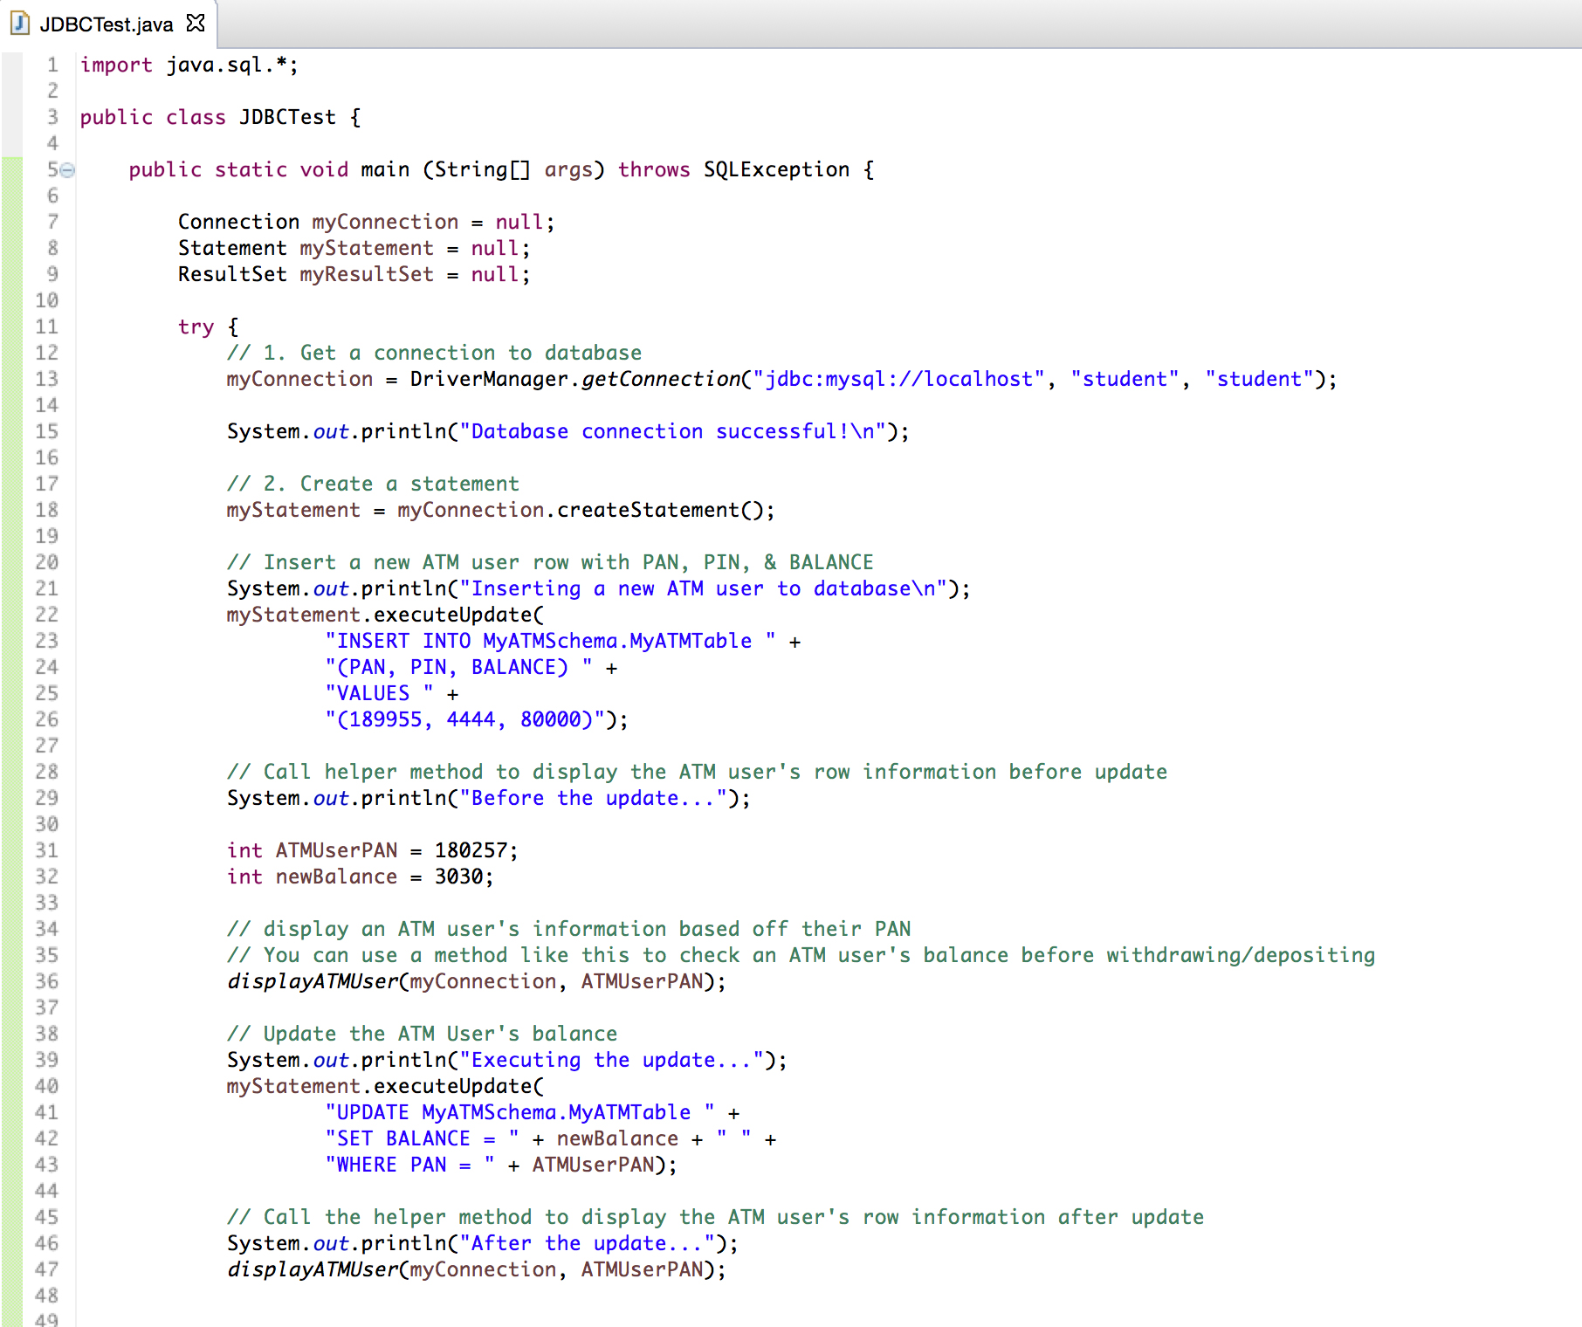

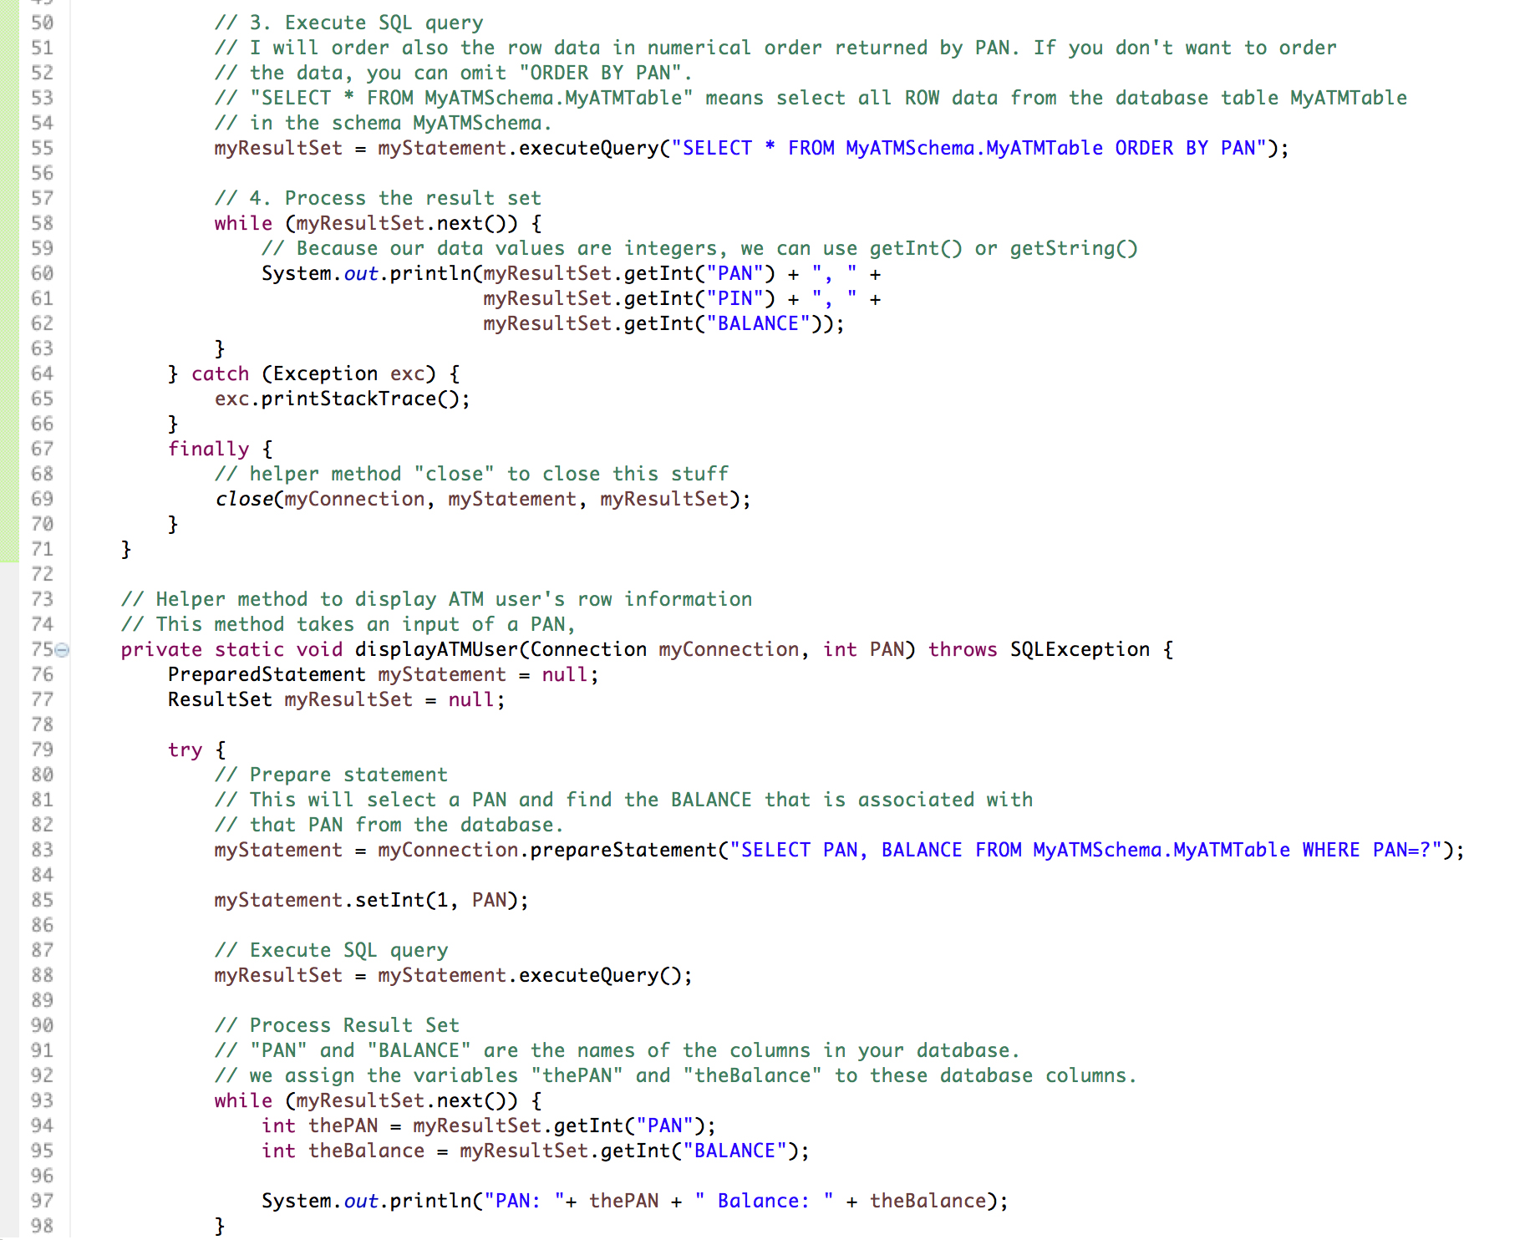

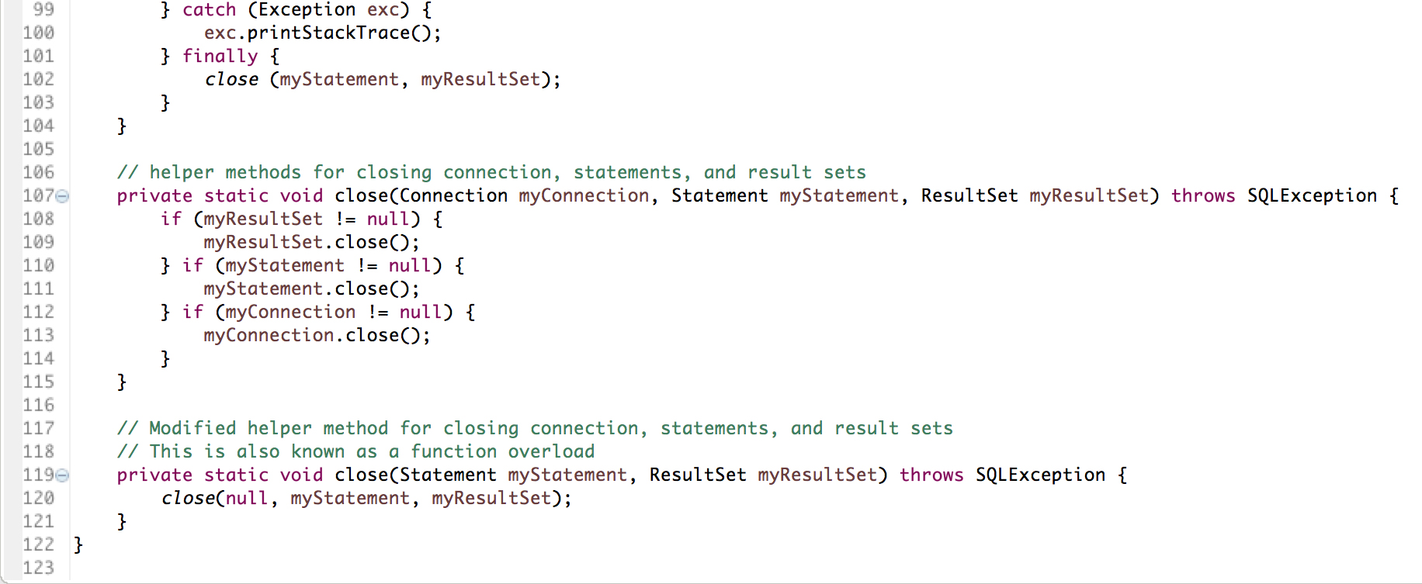

Console Output:

Database connection successful!

Inserting a new ATM user to database

Before the update...

PAN: 180257 Balance: 257000

Executing the update...

After the update...

PAN: 180257 Balance: 3030

180257, 2377, 3030

189011, 1234, 34000

189012, 9009, 785000

189014, 7777, 151000

189955, 4444, 80000

And that’s all you need to know! You can check your MySQLWorkbench to see the updated changes. Just click the lightning bolt icon to refresh the changes.